Name: Date:

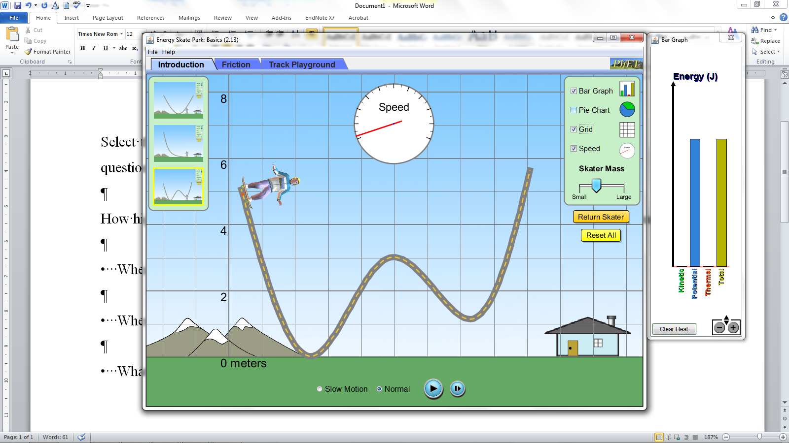

<http://phet.colorado.edu/sims/html/energy-skate-park-basics/latest/energy-skate-park-basics_en.html>

Click on Intro. Select this skate ramp with no friction. Select Bar Graph, Grid and Speed. Your screen should look like this Answer the following questions.

Q1 How high up the ramp in metres do you have to start the skater so he or she can get over the middle hump?____________________________________________________________________

________________________________________________________________________________________________________________________________________________________________

a. Where is gravitational potential energy the greatest?___________________________________

________________________________________________________________________________

________________________________________________________________________________

b. Where is kinetic energy the greatest?_______________________________________________

________________________________________________________________________________

________________________________________________________________________________

c. What happens if you change the skateboarder’s mass?_________________________________

________________________________________________________________________________________________________________________________________________________________

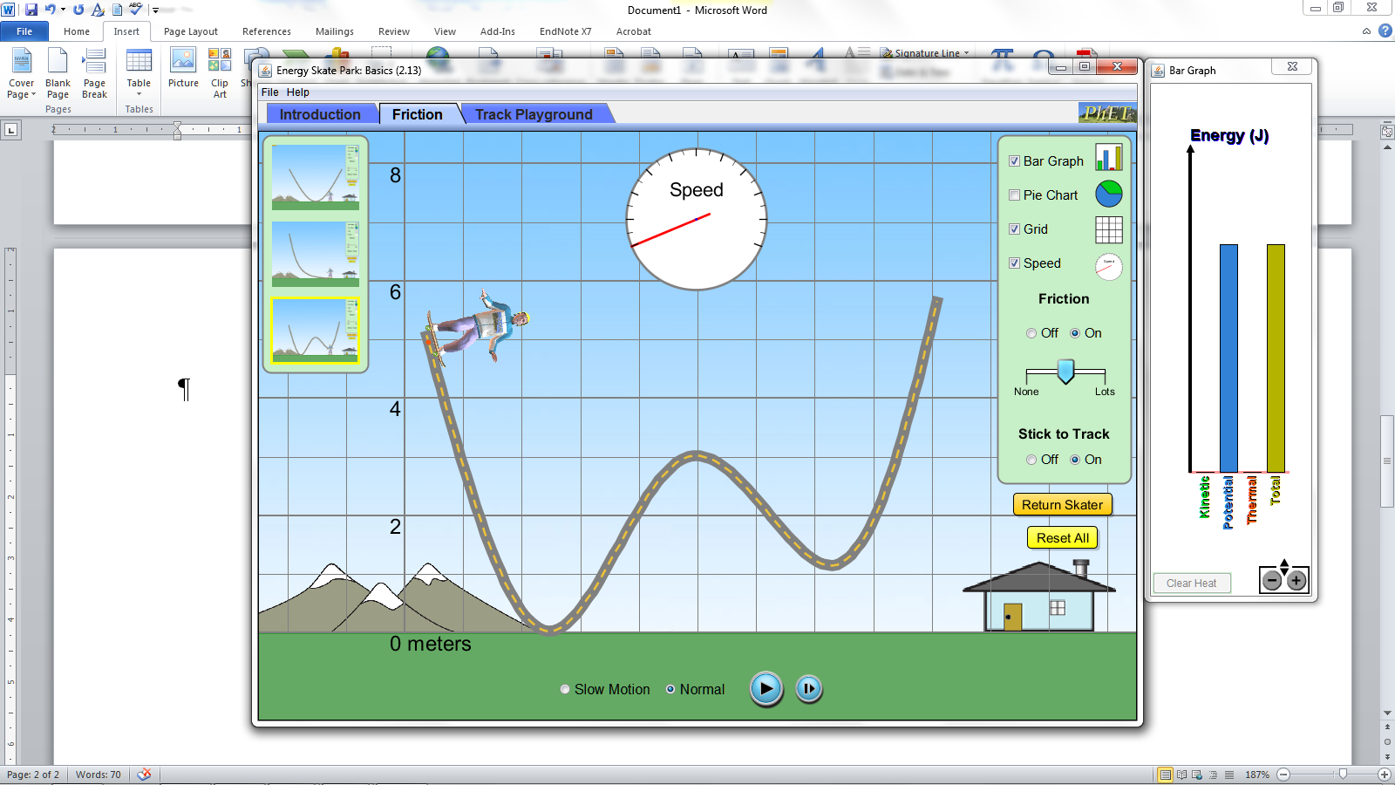

Now do the same again but apply friction.

Q2 How high up the ramp in metres do you have to start the skater so he or she can get over the middle hump?____________________________________________________________________

________________________________________________________________________________

________________________________________________________________________________

a. Where is gravitational potential energy the greatest?___________________________________

________________________________________________________________________________

________________________________________________________________________________

b. Where is kinetic energy the greatest?_______________________________________________

________________________________________________________________________________

________________________________________________________________________________

c. If energy cannot be created or destroyed, where does all the potential and kinetic energy go when we apply friction?____________________________________________________________

________________________________________________________________________________________________________________________________________________________________________________________________________________________________________________________________________________________________________________________________________________________________________________________________________________